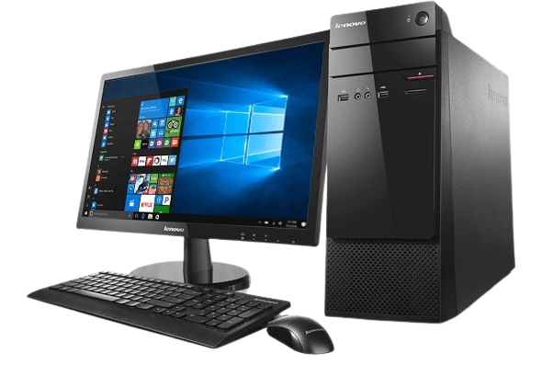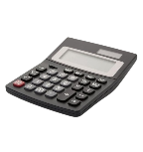

TECH 123-345

TECH 123-345

TECH 123-345

TECH 123-345

TECH 123-345

**SOUND SYSTEM**

TECH 123-345

Nunc tistiquescelerisque eiet intuena foucbus

Docec luctus melesuada cosectur impdiet

**APRIL – MAY 2016**

Donec luctus malesuada imperdiet

Nunc facuibus rhoncus felis,

50

**%**

OFF

**SALE**

BIG

**SOUND SYSTEM**

**$100**

$200



**SOUND SYSTEM**

**$100**

$200

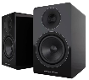

**SOUND SYSTEM**

**$100**

$200



**SOUND SYSTEM**

**$100**

$200



**SOUND SYSTEM**

**$100**

$200



**$100**

$200